Before installing and using the product, please read the Installation and User Manual.
Please keep this manual properly for future reference.

CrossDriver NTFS
Installation and Usage Instructions
(XR-DN-2025-08)



CrossDriver Limited

Contents

Chapter 1: Introduction 1
Chapter 2 System Requirements 1
Chapter 3 Supported Media 1
Chapter 4 Installing CrossDriver 2
● Step 1 2
● Step 2 2
● Step 3 3
● Step 4 4
● Step 5 4
● Step 6 5
● Step 7 5
● Step 8 6
● Step 9 7
● Step 10 8
● Step 11 8
Chapter 5 Activation and Registration 9
5.1 Register a CrossDriver Account 9
5.2 Activate CrossDriver NTFS 13
Chapter 6 Quick Start Guide 19
6.1 Automatic Installation 19
6.2 Spotlight Search 20
6.3 Formatting 21
6.4 Installation in Read-Only Mode 21
6.5 Record File Access Time 22
6.6 Preferences 23
6.7 Other Features： 24
6.7.1 Mount 25
6.7.2 Eject 25
6.7.3 Open 27
6.7.4 Pie Chart Display 29
Chapter 7 Uninstalling CrossDriver NTFS 30
Chapter 8 Frequently Asked Questions (FAQs) 31
Chapter 9 Contact Information 32

Chapter 1: Introduction
In the digital age, external hard drives and USB flash drives have become core tools for individuals and enterprises to store and transfer data. Whether for backing up massive work files, storing high-definition audio-visual resources, or exchanging data across devices, these portable storage devices play an indispensable role. However, in traditional usage, users often face format compatibility barriers—such as read-write restrictions on the NTFS format for non-Windows devices, or issues like cumbersome manual operations and unprotected data security—turning the convenient demand for "plug-and-play" into a fantasy.

To address this, this NTFS system is positioned as a "fast and convenient external hard drive assistant," creating a one-stop solution specifically for external hard drives and USB flash drives. It breaks down cross-platform read-write barriers and enables "easy reading/writing and plug-and-play": no complex settings are required—simply connect the device to smoothly access content stored in the NTFS format, significantly lowering the operational threshold. Meanwhile, for large-capacity storage needs, the system fully supports TB-level hard drives and high-speed USB flash drives; combined with optimized read-write algorithms, it ensures efficient and stable transfer of large files. In terms of data security, it has a built-in intelligent verification and error repair mechanism to reduce the risk of file corruption caused by unexpected power outages or incorrect operations. It also provides a concise and intuitive management interface, allowing operations such as partition adjustment and space monitoring to be completed with one click. Truly realizing the triple value of "large-capacity storage + data security + intelligent management," it fully meets your usage needs for external hard drives and USB flash drives.

Chapter 2 System Requirements
Before installing CrossDriver NTFS, you first need to check whether your system meets the minimum system requirements for installation. Both Intel and Apple versions of the system are supported, and the macOS version must not be lower than 10.15.
Supported file systems: All versions of Microsoft NTFS are supported (from Windows NT 3.1 to Windows 11).

Chapter 3 Supported Media
- Ultra-large capacity disks (currently tested up to a maximum of 10TB)
- IDE, SCSI, and SATA/eSATA disks
- SSDs (Solid-State Drives)
- Supports USB 1.0, USB 2.0, USB 3.0, USB 3.1, USB 3.2, and USB-C interfaces
- Various flash memory SD cards

Chapter 4 Installing CrossDriver

Step 1
First, visit our official website at https://www.crossdriver.com/ to download the installation package.
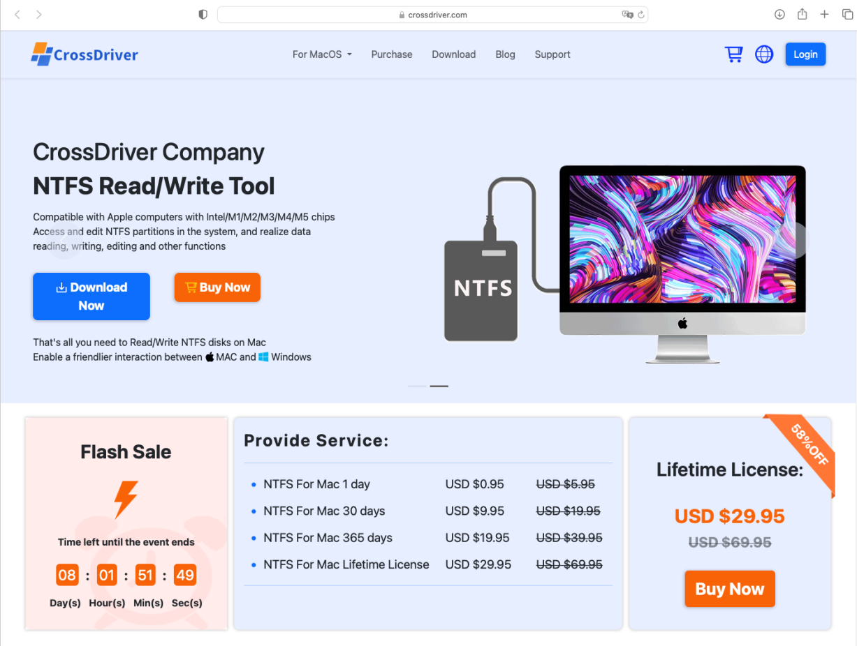Figure 1

Step 2
Run the downloaded installation package
CrossDriverNTFS-x.x.xxx.xxxx-(Intel+AppleSilicon).pkg, and click "Continue".
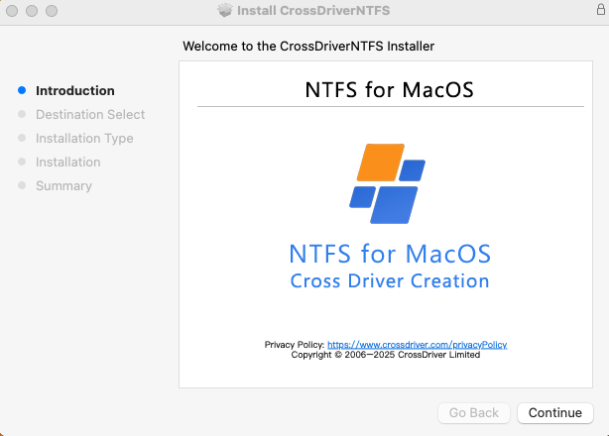
Figure 2

Step 3
Click "Install"
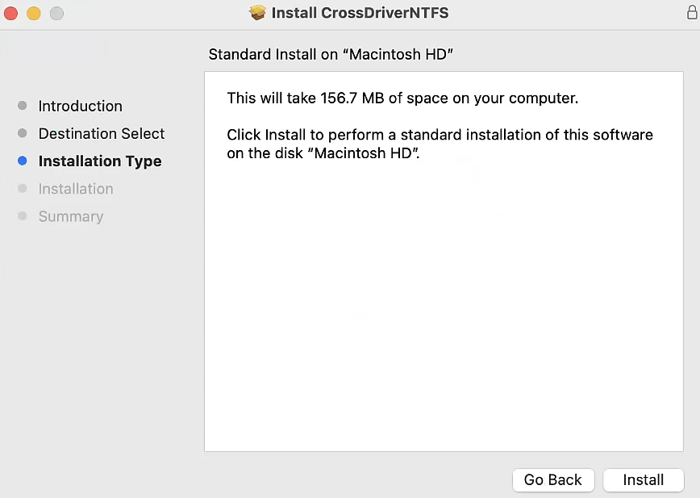
Figure 3

Step 4
Enter the password and click "Install Software".
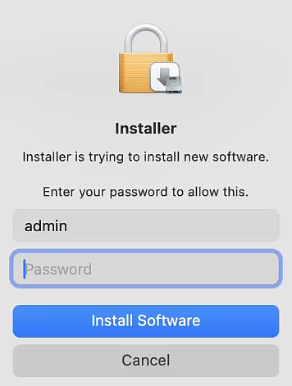
Figure 4

Step 5
Click "Open System Settings"

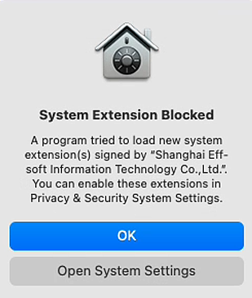
Figure 5

Step 6
Select "Allow"
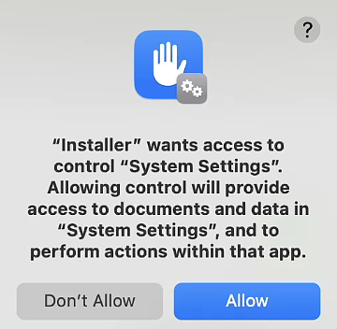
Figure 6

Step 7
On the Privacy & Security screen, select "Enable System Extensions"

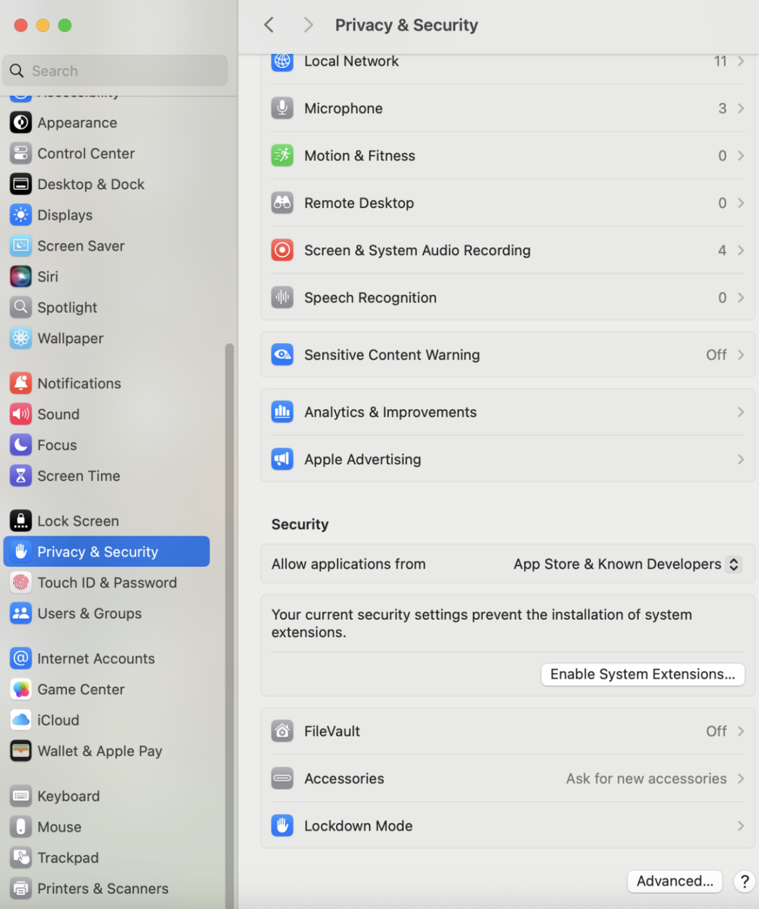
Figure 7

Step 8
Enter the password and click "Modify Settings"
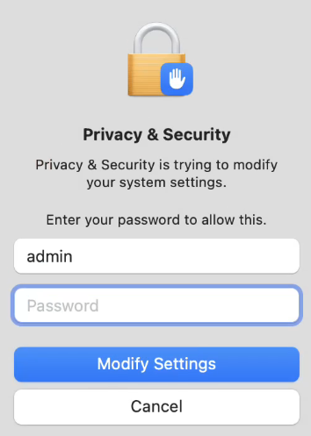
Figure 8

Step 9
At this point, the system will prompt you that you need to modify "Security Settings" in Recovery Mode. Please click "Shut Down". After the shutdown is complete, follow the method shown in Figure 9 to enable kernel extensions in "System Security Policy", then proceed to the next step.
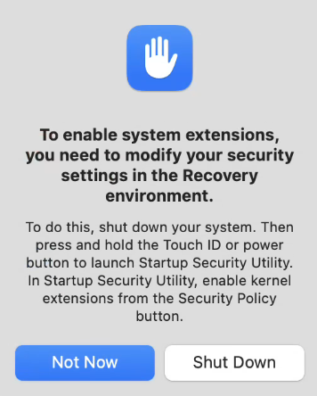
Figure 9

Step 10
After enabling the kernel extensions, return to the "Privacy & Security" screen and allow our kernel extensions
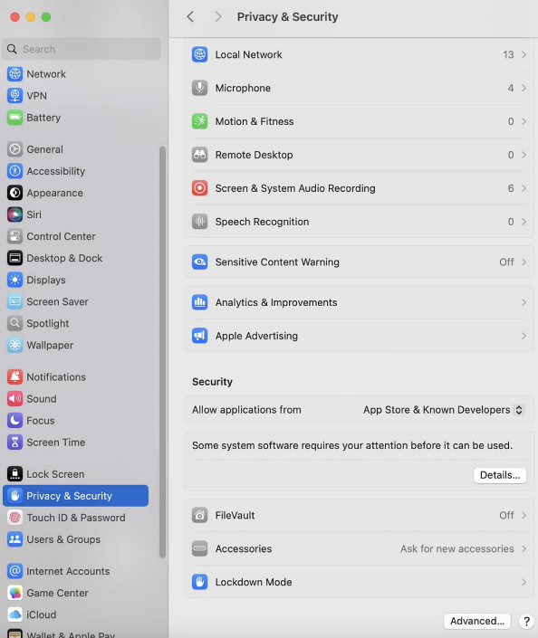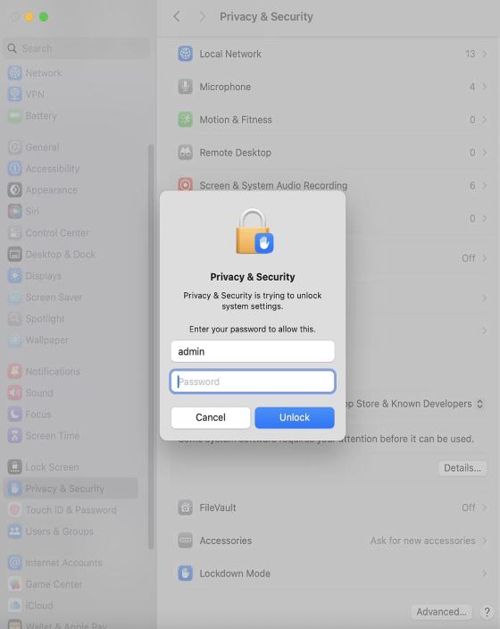
Figure 10

Step 11
After allowing it, restart the computer to complete the installation. At this point, most features will still not be available and require activation before use.

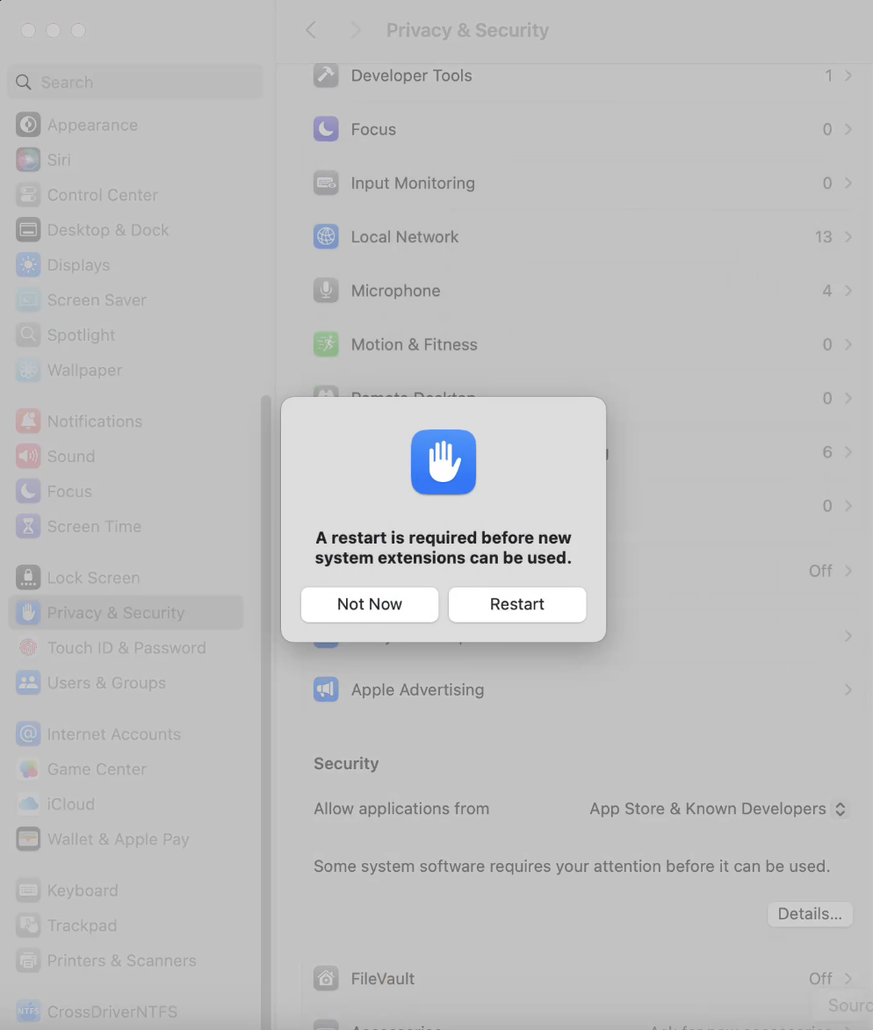
Figure 11

Chapter 5 Activation and Registration
This product requires activation with a serial number while connected to the internet. The serial number will be bound to the computer's machine code:

A Personal edition serial number is only allowed for use on one computer.
An Enterprise edition serial number can be used on multiple computers.

Serial numbers are automatically generated after payment. You can purchase daily, monthly, annual, or lifetime licenses according to personal or enterprise needs.

Register a CrossDriver Account
- Open a browser, visit the CrossDriver official website at https://www.crossdriver.com/, and click the "Log In" button.

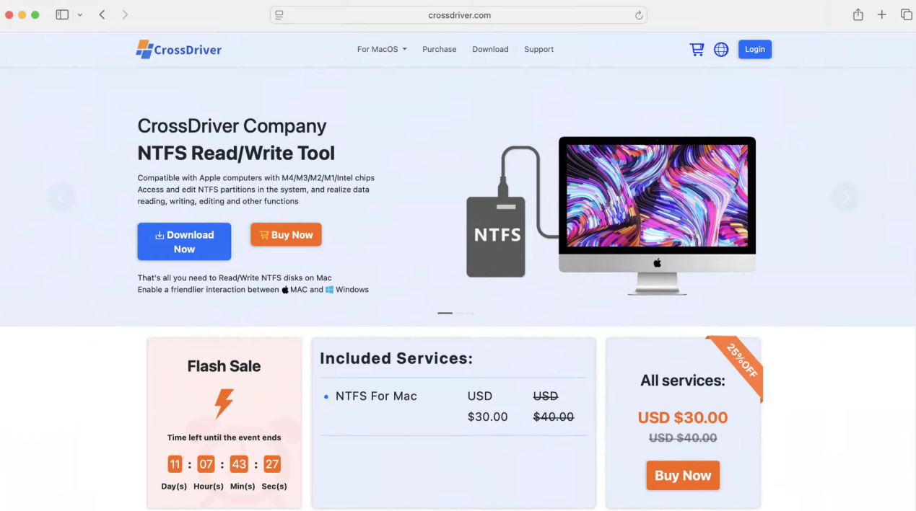
Figure 12

- Click "Register Now" to sign up. You can register using an email account, or log in directly with your Google or Twitter account.

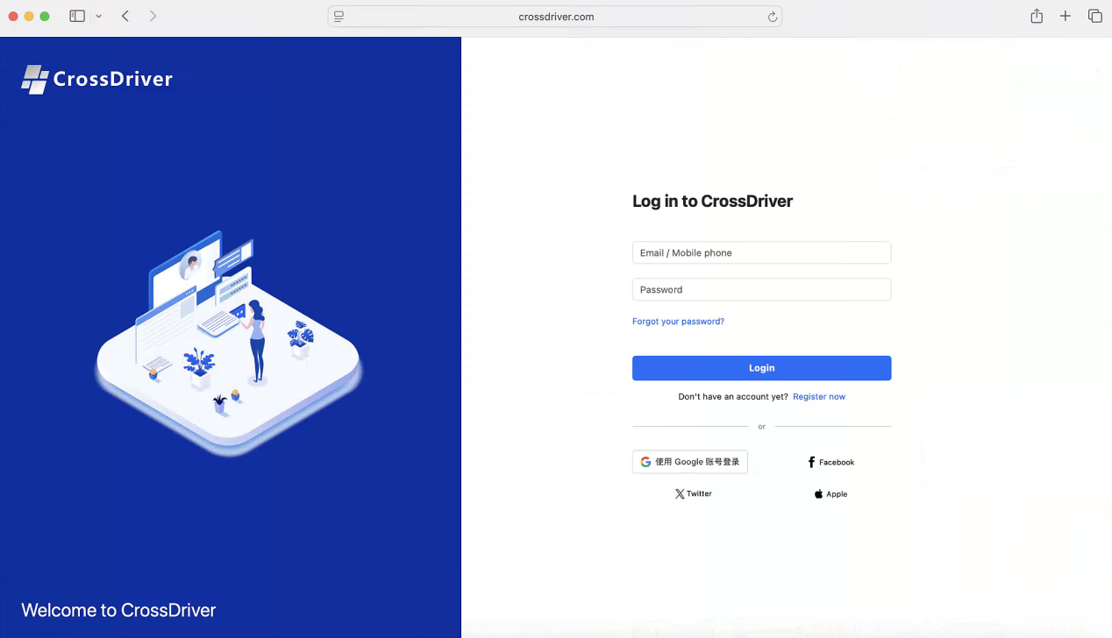
Figure 13 Create an Account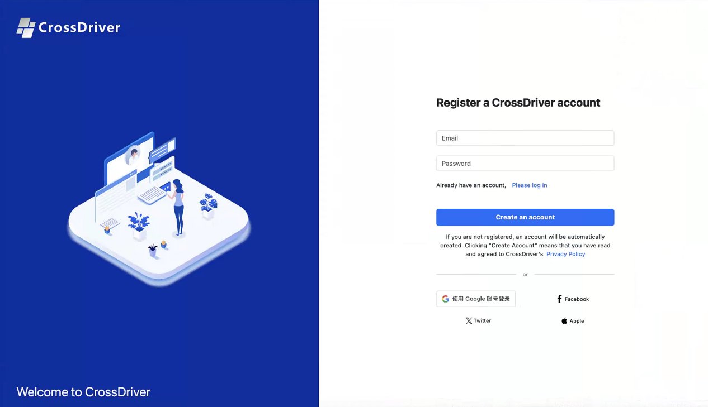
Figure 14

- To change your password, please first log in to the Crossdriver official website with your registered account. After logging in, go to your personal center, click "Change Password" on the profile page, enter your new password, and the password change will be completed.
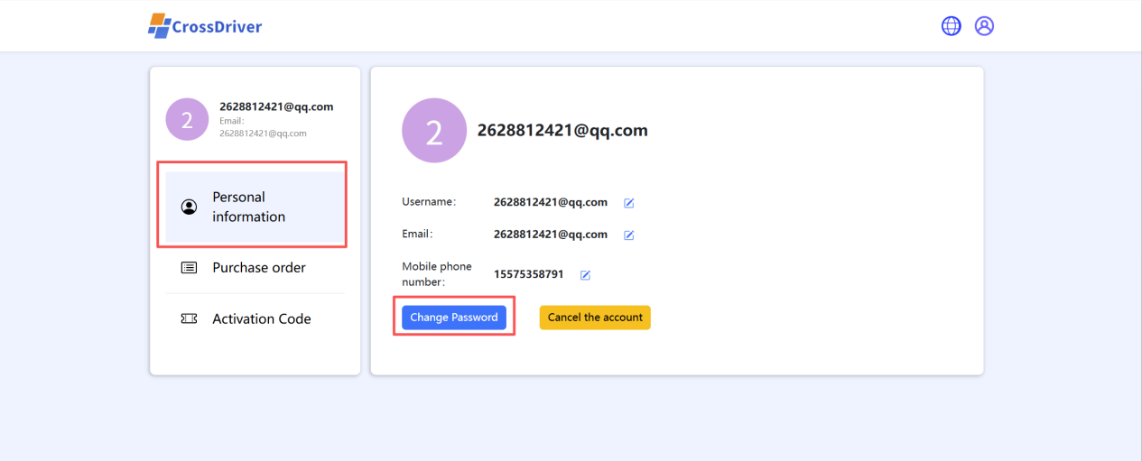
Figure 15 Change
Password

- Forgot your password? Please click "Forgot Password" on the login page. After verifying your account information, you can set a new password to log in.
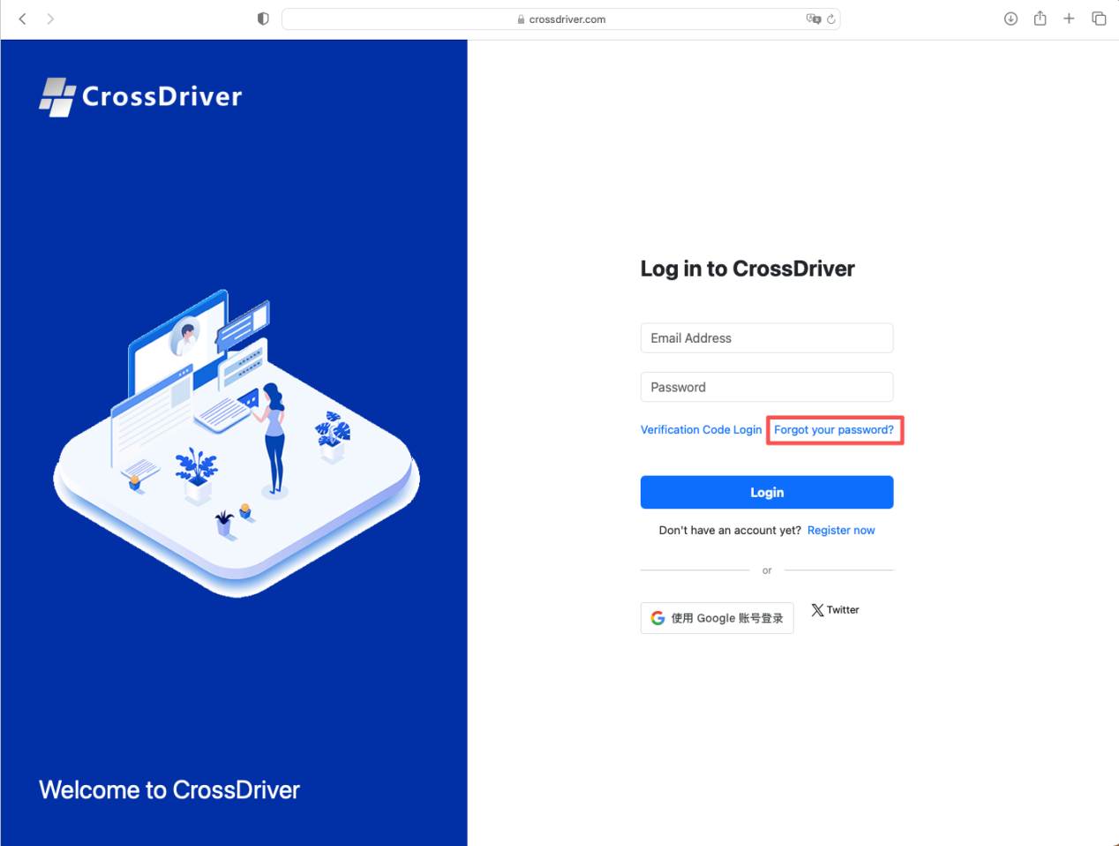
Figure 16 Change
Password

Enter your registered email address and click “Send Verification Code”.
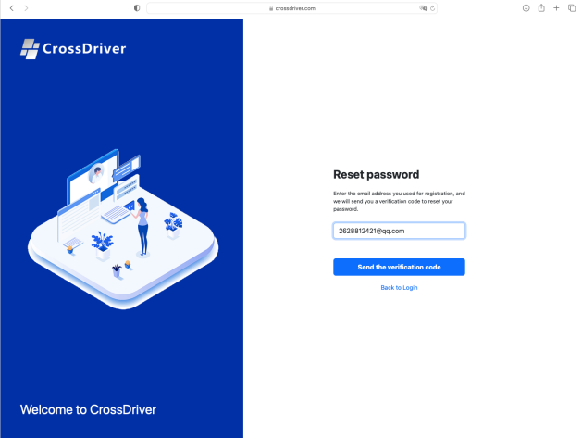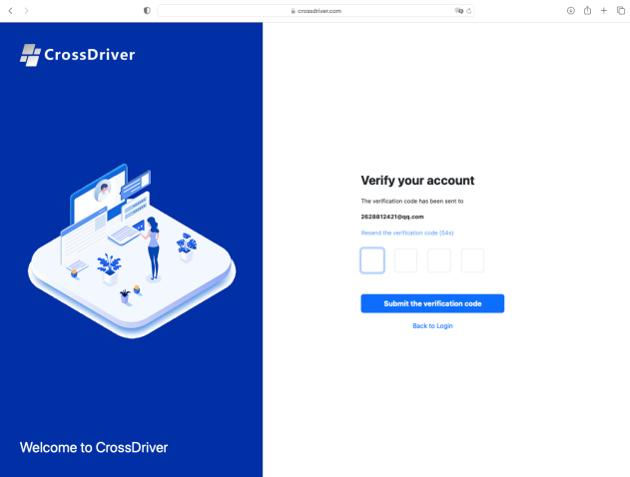
Figure 17

After entering the code received in your email, click “Submit Verification Code” to complete the verification.
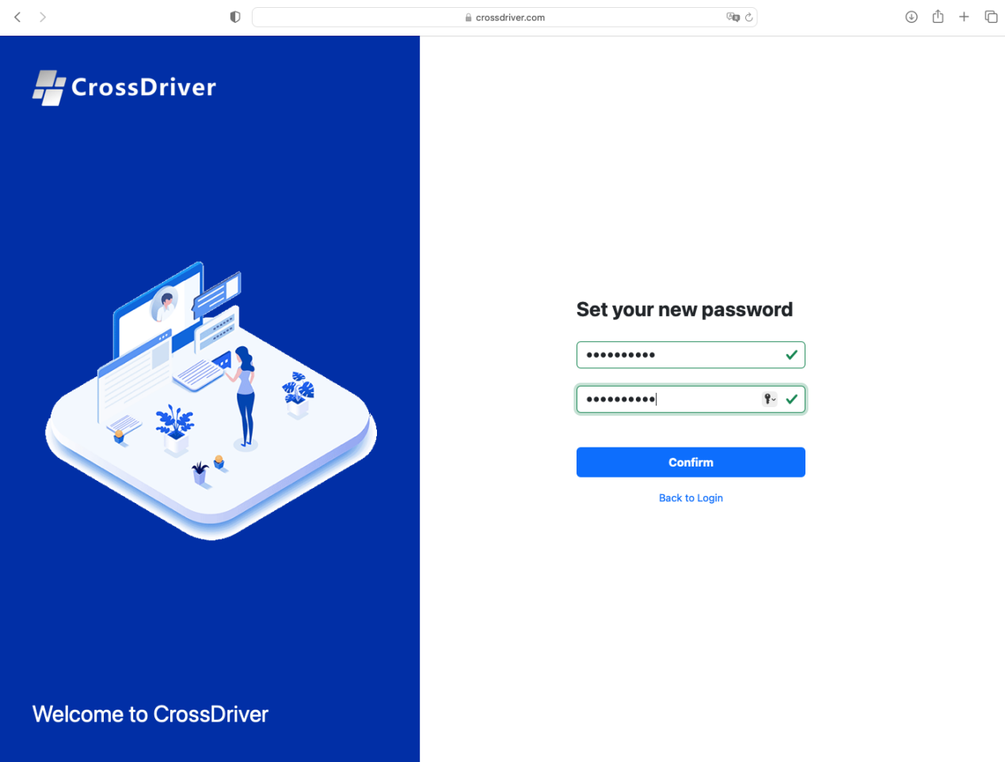
Figure 18 Set New Password

Activate CrossDriver NTFS
Option 1：

- Click the "Not Activated" button at the top to access the activation screen.

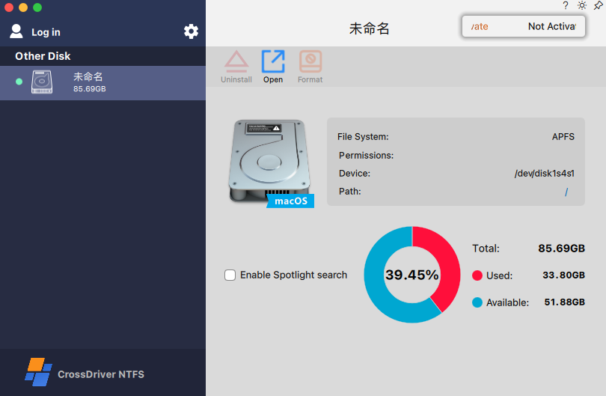Figure 19
- After accessing the activation screen, you can either manually enter the serial number purchased on the official website to activate the product, or use a suitable payment method to make a purchase on this page. Upon successful payment, a serial number will be automatically obtained and the product will be activated automatically.
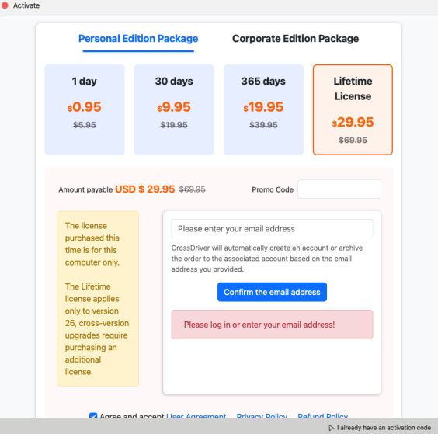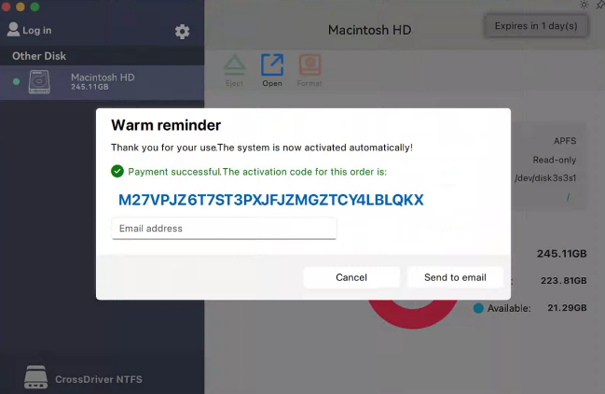
Figure 20

Option 2：

- First, open the official CrossDriver website and log in with the account you registered in Section 5.1. Then return to the homepage and click either "Buy Now" or "Purchase" to navigate to the purchase page.
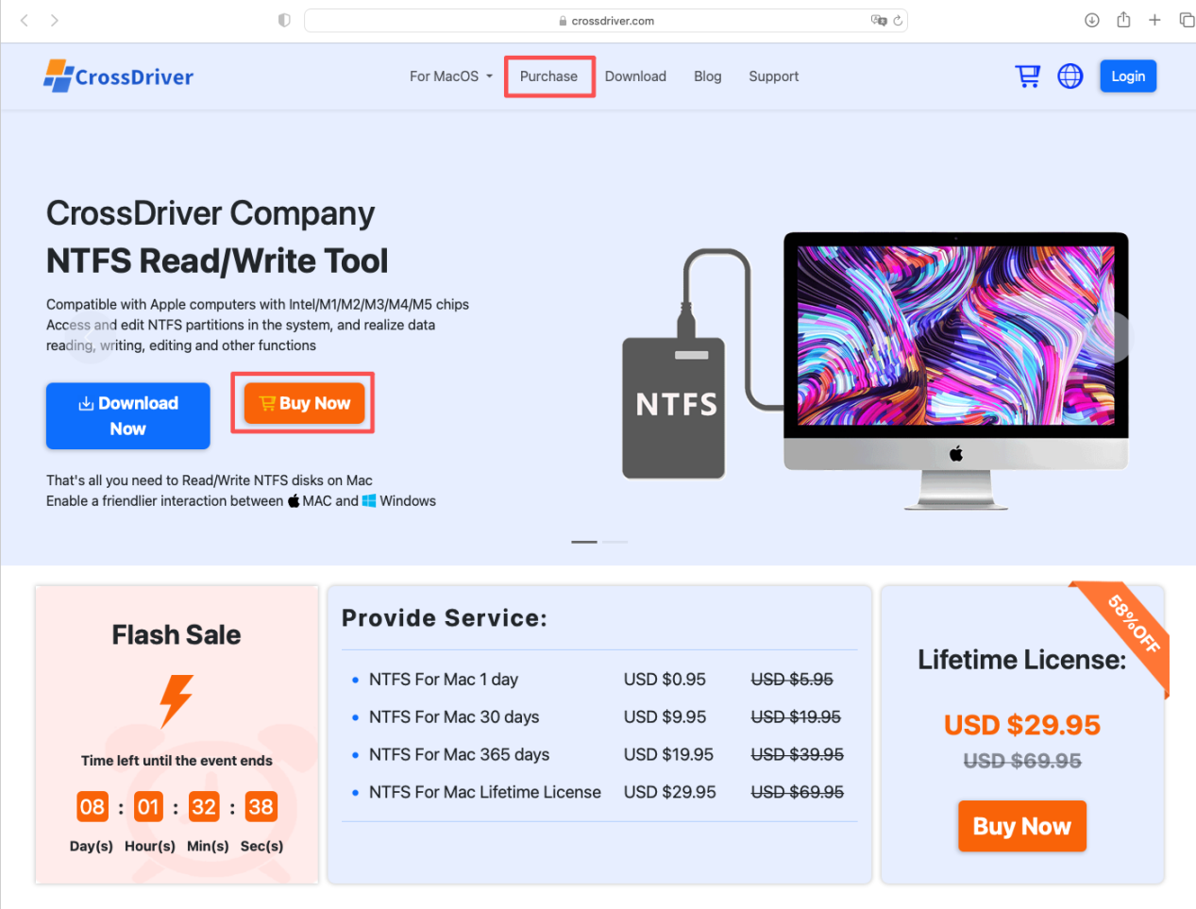、
Figure 21
After payment is completed, an activation code will be displayed. You can use this code to activate NTFS Assistant. We recommend that you enter your email address to have the activation code sent to your inbox for backup. If you choose not to send it to your email, the activation code will still be saved in your account information.

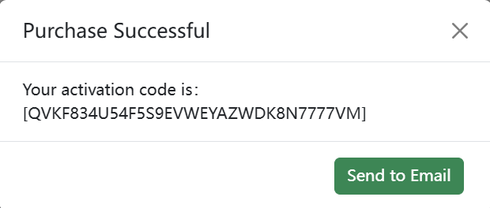
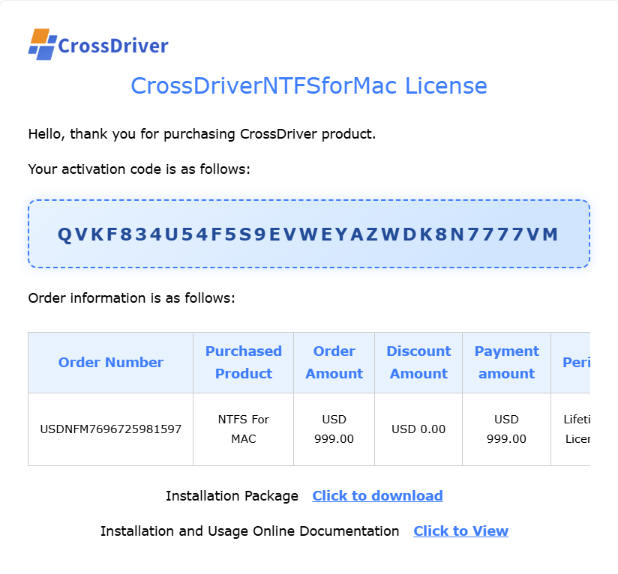
Figure 22
Click the user avatar in the top-right corner, then select User Center to view your purchased order information and activation codes.
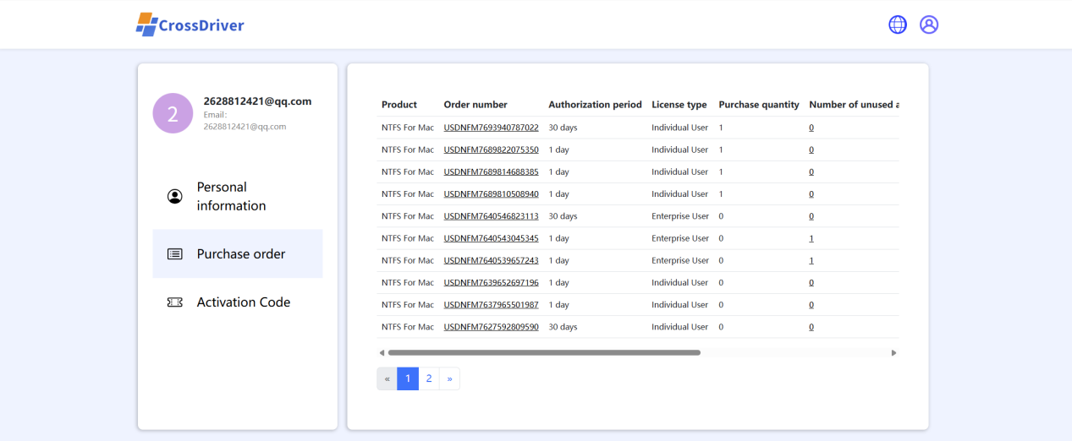

Figure 23
Finally, log in to your registered account in NTFS Assistant. Once logged in, your activation code will be retrieved automatically.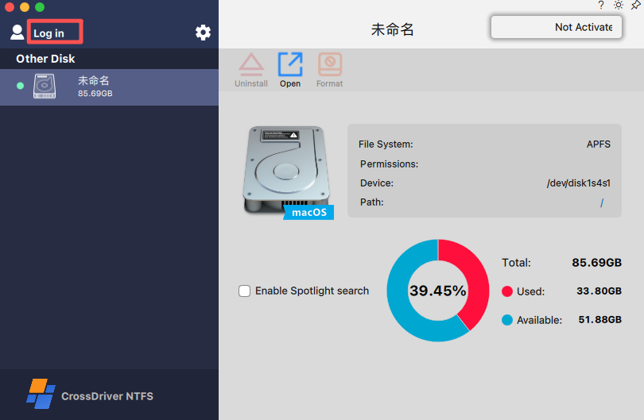
Figure 24
Enter your account and password, then click “Log In”.
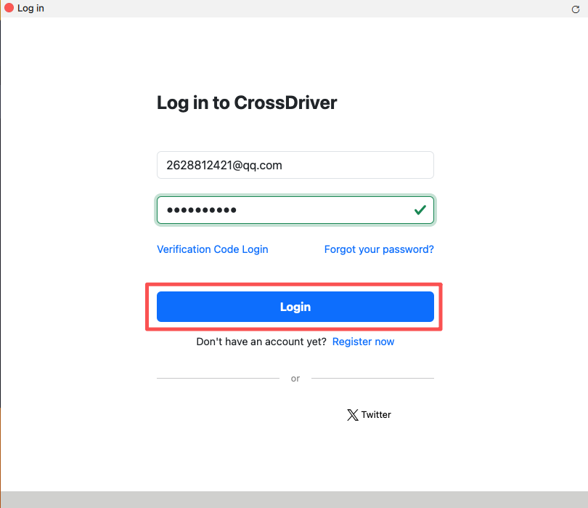Figure 25
After logging in, all activation codes for this account will be displayed in a pop-up window. The first activation code will be selected by default; click “Activate” to start using it. To use other activation codes under this account, click “Get More Authorizations”, select the desired activation code, and then click “Activate”.
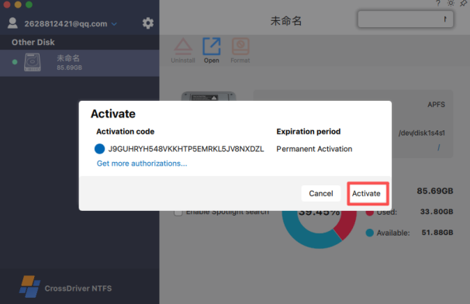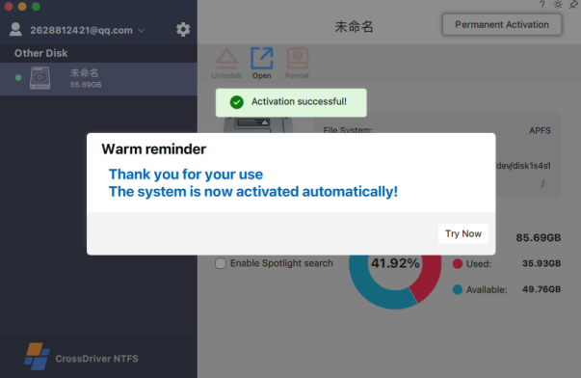
Figure 26
- Deauthorize
If you need to switch to another computer for Enterprise Edition authorization, you must first deauthorize the license on the activated computer. Only after deauthorization can you activate it on a new computer (this applies only to Enterprise Edition authorization). You can access the deauthorization interface by clicking the license remaining time at the top of the assistant, as shown in the figure below:
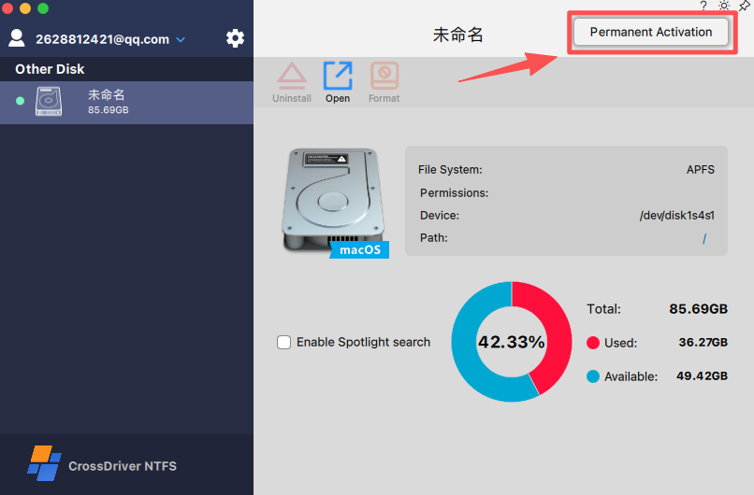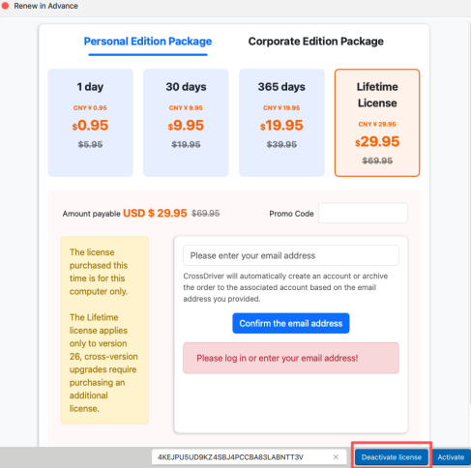
Figure 27

Chapter 6 Quick Start Guide

Automatic Installation
After the software is activated, connect an NTFS disk, and the NTFS driver will be loaded automatically. Once mounted, you can read and write files in the disk normally (such as creating, modifying, renaming, copying, moving, deleting, etc.) just like accessing the native macOS system.

If "Automatic Installation" is not checked, the NTFS disk driver will not be loaded automatically when the disk is connected. In this case, you can only read files in the disk and cannot perform write operations. To load the driver, you can also click the "Load" button at the top to load it manually.

Before loading (unable to write files)
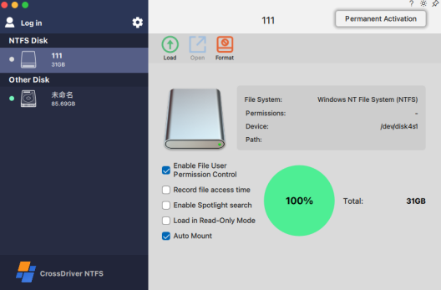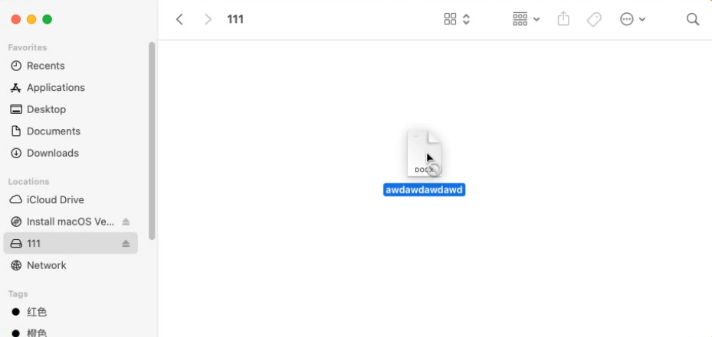
Figure 28
After loading (able to write files)
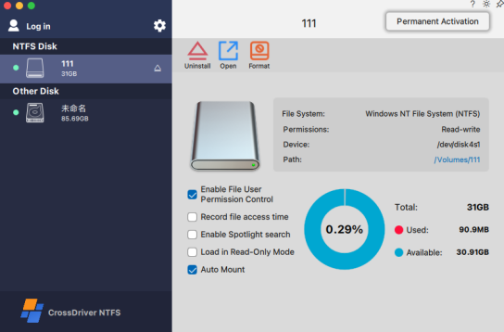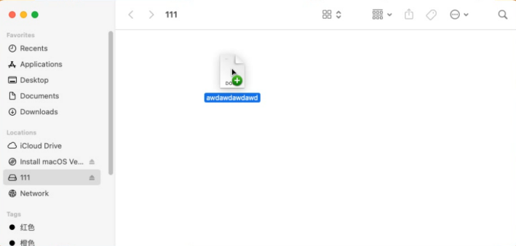
Figure 29

Spotlight Search
Spotlight Search has achieved seamless integration with the Mac system's Spotlight Search function. It can directly call the native Spotlight Search capability of Mac to quickly retrieve various types of content in NTFS-formatted storage devices (such as external hard drives, external SSDs, etc.), providing users with an efficient and convenient file search experience.

It directly reuses the activation methods of Mac's system Spotlight Search (Command + Space, clicking the magnifying glass icon in the menu bar, etc.). No additional learning of operation logic is required—simply enter keywords to trigger the search for content in NTFS devices.
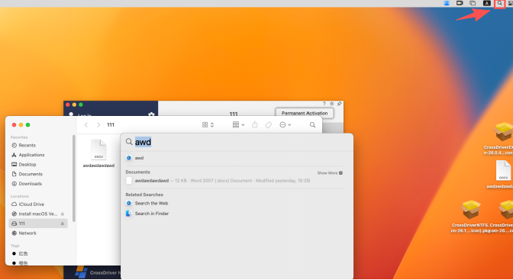
Figure 30

Formatting
The Format function supports formatting disks in EXT3, EXT4, FAT32, NTFS, and exFAT formats to NTFS. Once a format operation is performed, all files on the disk will be completely deleted. Please back up any necessary files before proceeding with formatting. By default, the disk name displayed during formatting is the original name; you may also enter a new disk name. If the disk name field is left blank, the system will automatically assign the name “Untitled”.
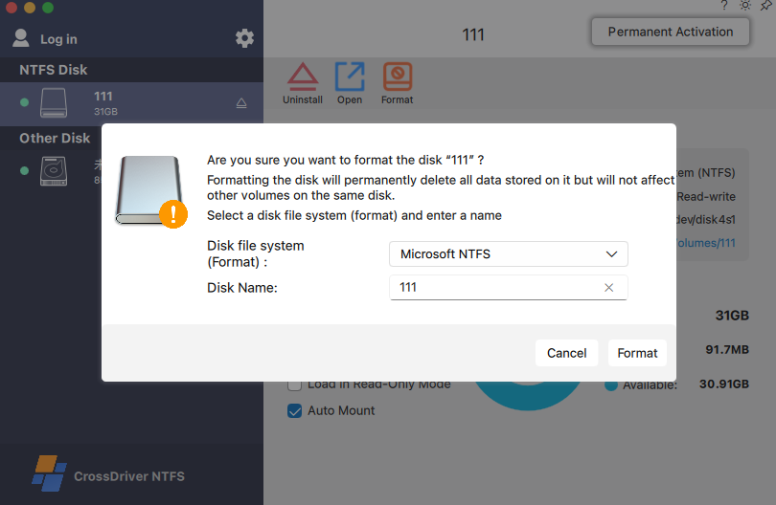
Figure 31

Installation in Read-Only Mode
The "Install in Read-Only Mode" function is mainly designed to keep the NTFS disk in its original read-only state. You only need to enable the read-write mode when you need to write files.

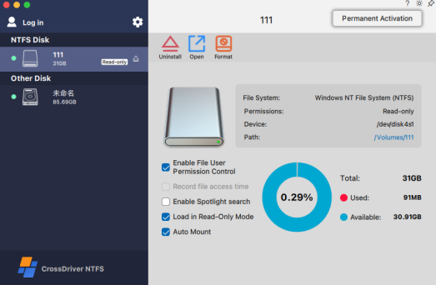
Figure 32

Record File Access Time
Once this function is enabled, the file access (open) time will be displayed only after files on the NTFS disk have been read. You can view the last open time by right-clicking a file on the NTFS disk and selecting “Get Info”. This information is unavailable if the function is not enabled. You may also view it by running stat -x [file path] in the terminal.
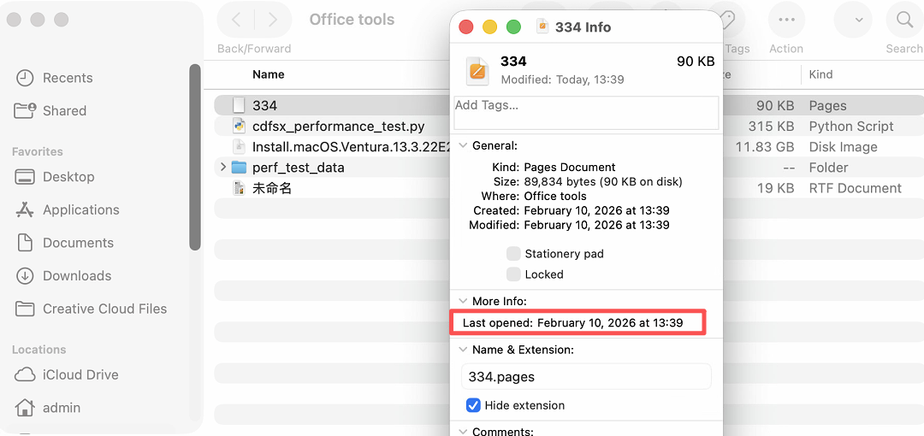
Figure 33 Show Info / View Details

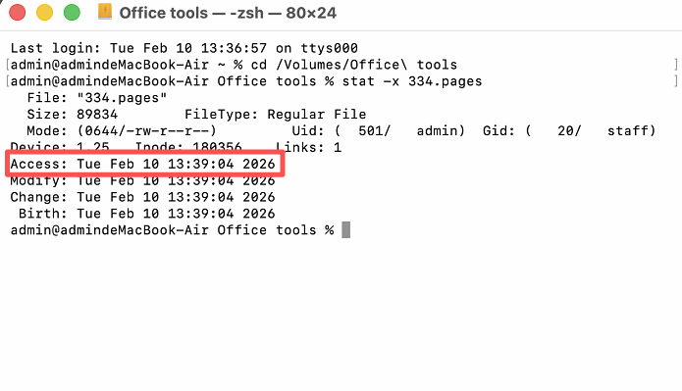
Figure 34 View via Terminal Commands

Preferences
The preferences settings of CrossDriver NTFS are mainly divided into three categories of functions: General, Updates, and Notifications.

- General: Includes functions such as displaying the activation status of the CrossDriver NTFS driver, uninstallation, enabling/disabling the menu bar icon, language selection, and appearance selection.
- Updates: Contains functions for assistant updates and assistant operation log collection.
- Notifications: Used to set the notification prompts of the assistant.

In the figure below, "CrossDriver NTFS is Enabled" indicates that the kernel of CrossDriver NTFS has been loaded. If it shows "Not Enabled", please go to System Preferences > Security & Privacy to enable it.

The "Uninstall" function is used to uninstall the CrossDriver NTFS assistant. After uninstallation, the NTFS disk will no longer have write permission.

The "CrossDriver NTFS Menu" function allows you to disable the menu bar icon and re-enable it at any time.

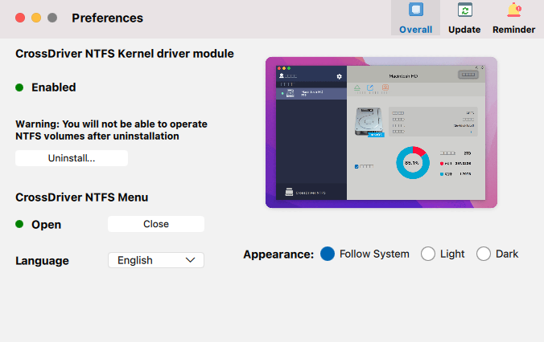
Figure 35

Update Function：The Update function enables immediate version upgrading after we release a new version.

This page also includes the functions of collecting and uploading analytics data. After checking "Upload Analytics Data", the background running logs of CrossDriver NTFS will be automatically sent to the official technical team 5 minutes after each system startup. If you have an urgent issue that requires immediate analysis, you can manually click the "Upload Analytics Data" button; once clicked, the logs will be sent to the official technical team right away.

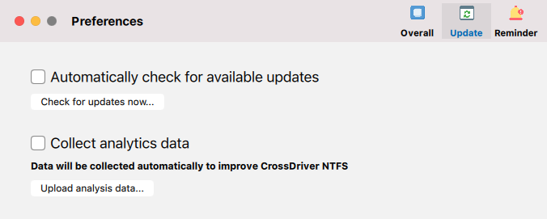
Figure 36
The reminder function will provide corresponding alerts by default in the following situations shown in the figure. If the checkbox is unchecked, no alerts will be given.
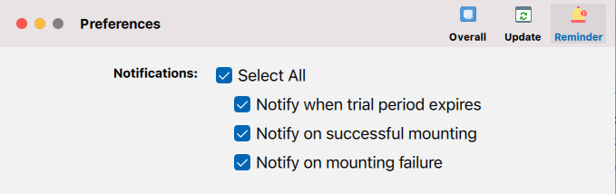
Figure 37

Other Features：

Mount
"mount" here refers to manually mounting the disk. Read and write operations on the NTFS disk can only be performed after the disk has been successfully mounted. You can mount the disk by clicking the Mount button on the main interface.
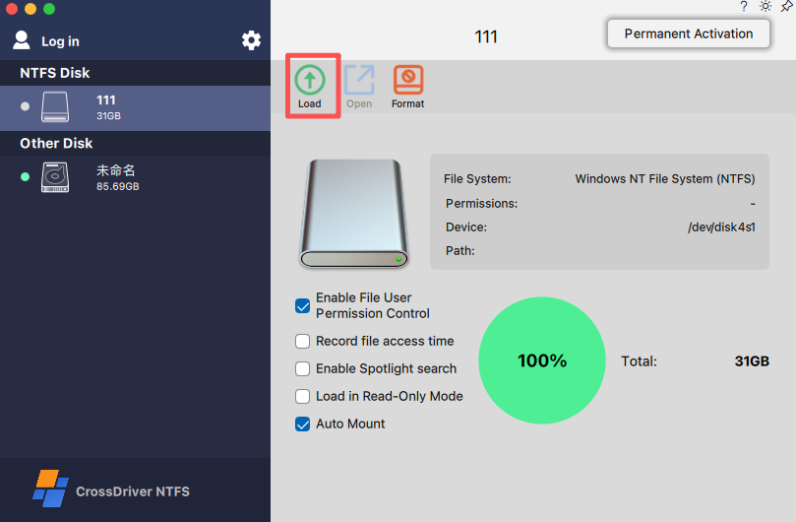
Figure 38

Eject
"Eject" refers to safely ejecting a mounted disk. There are three ways to eject a mounted disk using our CrossDriver NTFS.

Option 1: Eject via the **Eject** button on the main interface.
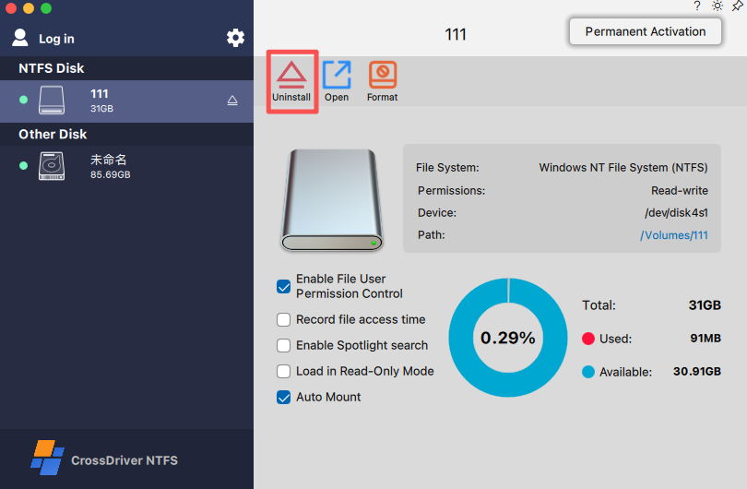
Figure 39

Option 2: Eject via the button  in the NTFS disk menu.
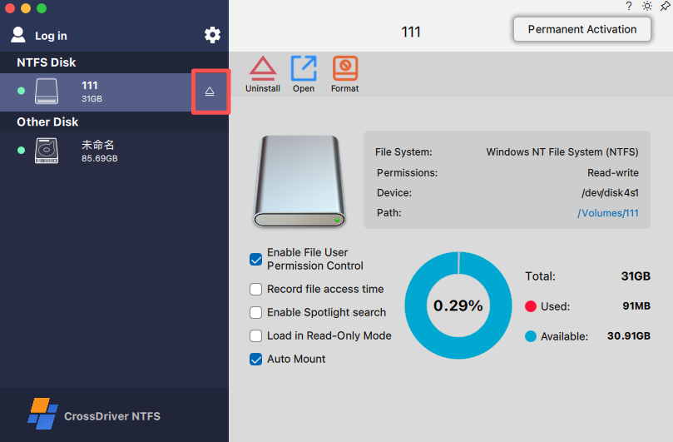
Figure 40

Option 3: Right-click the icon in the menu bar, select the specified disk to eject, or click Eject All.
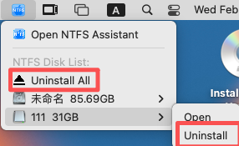
Figure 41

Open
"Open" refers to opening the disk directory. There are three ways to quickly open a specified disk using our CrossDriver NTFS. This feature is available regardless of whether the disk is NTFS or whether the software is activated.

Option 1: Open the disk via the Open button on the main interface
In the disk management interface, first select the disk you want to open. The interface will then display relevant information about the disk. Locate the Open button in the information area and click it to open the corresponding disk.

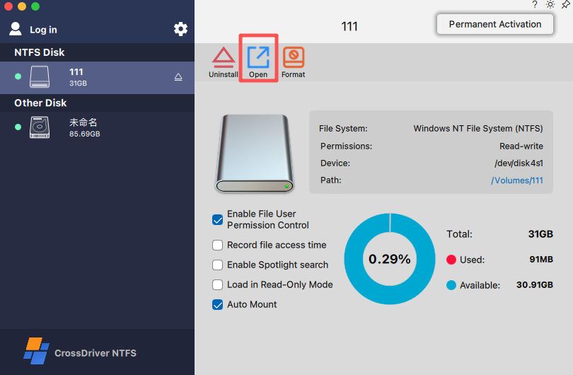
Figure 42

Option 2: Open the disk via the path
In the disk management interface, first select the disk you want to open, then click the information displayed in the path bar to open the disk.
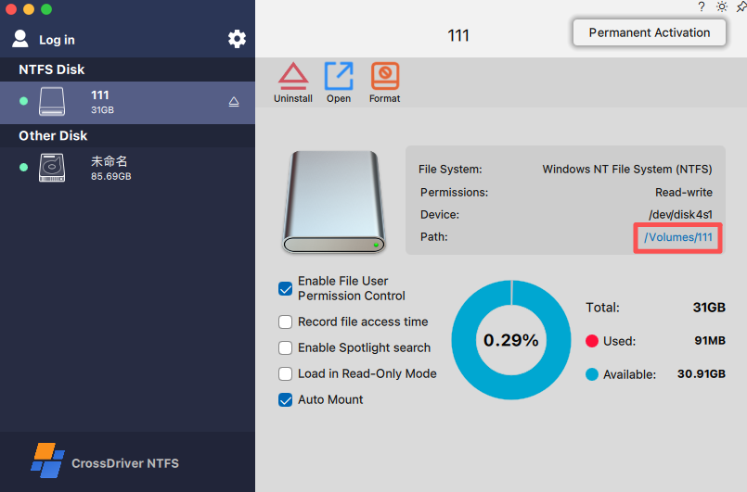
Figure 43

Option 3: Open the disk via the right-click menu
Right-click the icon in the menu bar, hover the mouse over the disk you want to open, and click Open to open the corresponding disk.
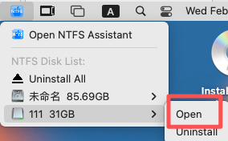
Figure 44

Pie Chart Display
This pie chart is used to visually present the storage usage of the selected disk. The red segment represents the used storage space, while the blue segment represents the available storage space. Through distinct colors and their respective proportions, it clearly shows the current storage occupation and remaining capacity of the disk, enabling users to quickly grasp the disk space utilization status and better plan operations such as file storage.
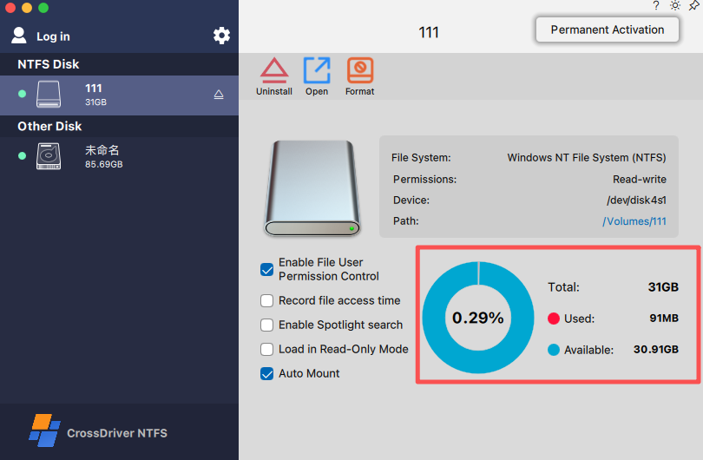
Figure 45

Chapter 7 Uninstalling CrossDriver NTFS
If you do not intend to use CrossDriver NTFS, you can click the settings button shown in the figure below. After opening it, you will see the "Uninstall" option—click it to complete the uninstallation.

If you may need to use the software again in the future, please copy the serial number first. You can still use this serial number to activate CrossDriver NTFS after reinstalling it (for purchases made with a CrossDriver account, the serial number will be saved in your account information).

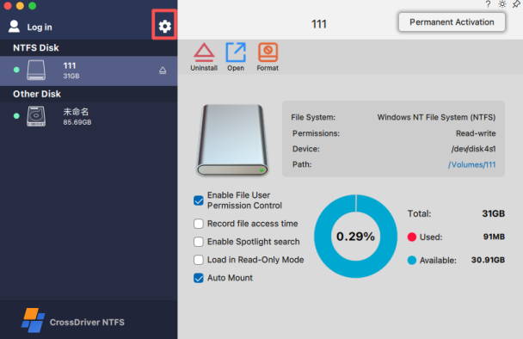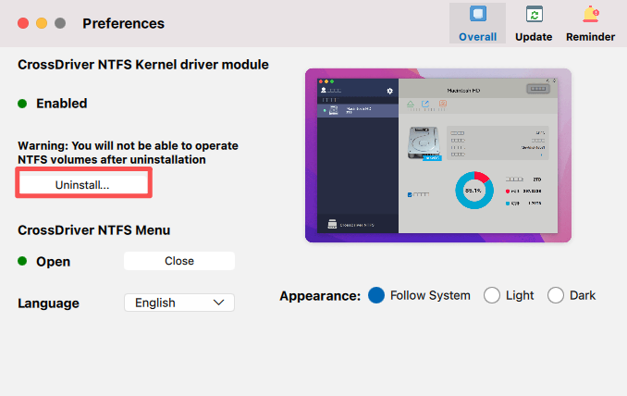
Figure 46

Chapter 8 Frequently Asked Questions (FAQs)
If the kernel is not permitted, the status shown in the figure below will be displayed. Please click "Enable NTFS for Mac", afterward, you will be redirected to the "Security & Privacy" settings to allow the kernel of our software.

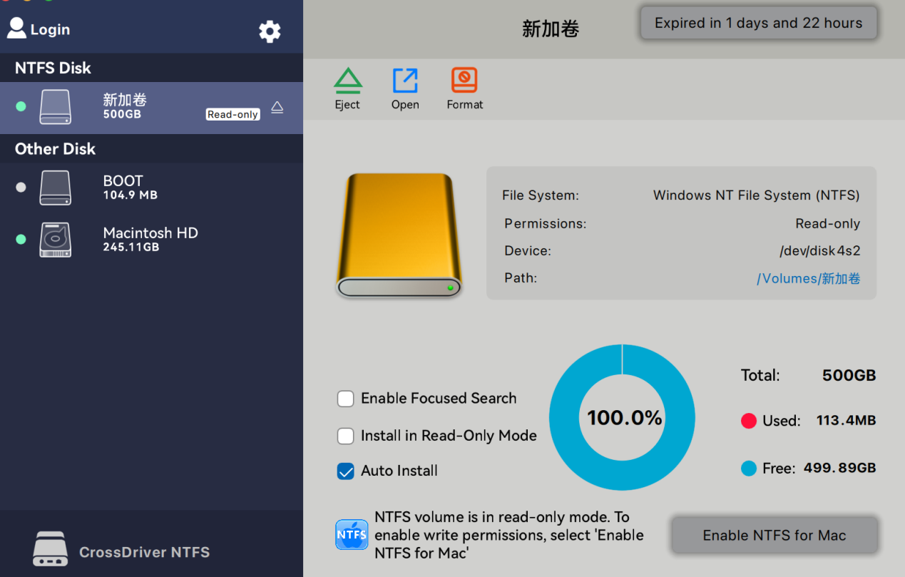Figure 47

Chapter 9 Contact Information

Business Cooperation:business@crossdriver.com
Technical Support:support@crossdriver.com


